Your “Everything You Need to Know”
User's Guide
For Managers & Supervisors

Conversations
that | Matter
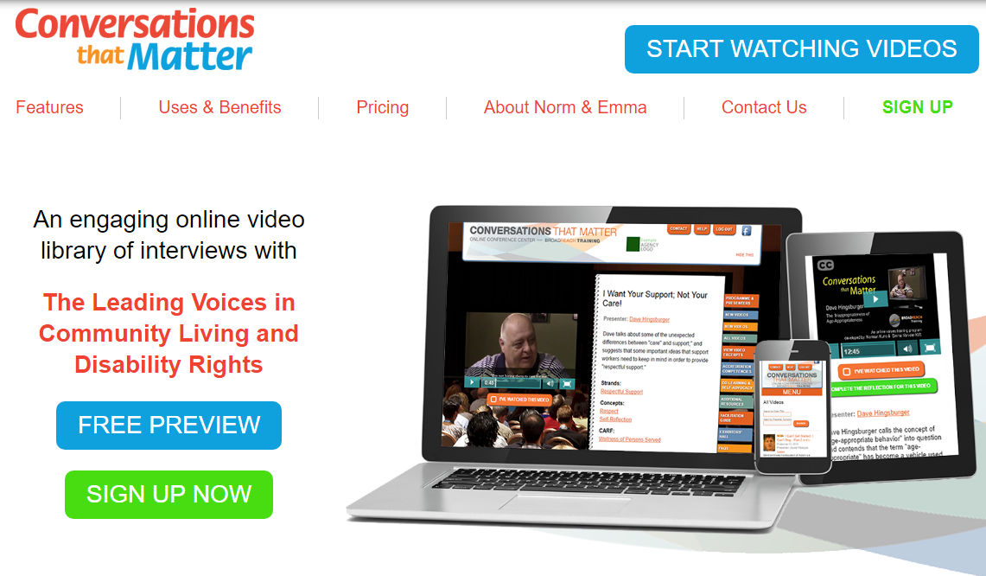

Come join us for Conversations…that Matter

Table of Contents
EXECUTIVE DIRECTOR'S MESSAGE 5
WELCOME TO CONVERSATIONS THAT MATTER 7
USING CONVERSATIONS THAT MATTER 9
LOGGING ON TO CONVERSATIONS THAT MATTER FOR THE FIRST TIME 11
GETTING YOUR INITIAL USERNAME AND PASSWORD 11
WHAT IF I CAN'T FIND THE EMAIL WITH MY TEMPORARY PASSWORD? 11
HOW DO I GET A NEW PASSWORD? 12
HOW DO I CHANGE MY EMAIL ADDRESS? 13
WHAT DO I DO WHEN I GET AN ERROR MESSAGE WHEN I TRY TO LOGIN? 14
LOGGING IN TO CONVERSATIONS THAT MATTER 15
HOW TO SELECT & WATCH A VIDEO 16
PLAYING A VIDEO 17
MARKING A VIDEO AS "WATCHED" 18
COMPLETING THE REFLECTION QUESTIONS 19
SELECTING VIDEOS FROM A PLAYLIST 20
ADDING VIDEOS TO A PLAYLIST 21
REMOVING VIDEOS FROM A PLAYLIST 22
VIEWING AGENCY REPORTS 23
YOUR AGENCY CONTACTS 24
RESPONSIBILTIES OF REPS AND COORDINATORS 25
FACILITATING DISCUSSIONS 27
IDEAS FOR FACILITATING ENGAGING AND FUN DISCUSSIONS 29
CONVERSATIONS THAT MATTER FACILITATED DISCUSSION FORM 30
SUGGESTIONS FOR FACILITATING CONVERSATIONS 31
FACILITATION QUESTIONS 32
PROCESSING MODALITIES 33
VIDEOS, TOPICS, & SUGGESTIONS 35
INTRODUCTORY VIDEOS 36
CONTINUED LEARNING VIDEOS 38
OTHER TOPICS 40
VIDEOS SUGGESTIONS, AS RECOMMENDED BY THE ##PHSS CORE GROUP 41
TROUBLESHOOTING & STAFF CHANGES FORM 42

EXECUTIVE DIRECTOR'S MESSAGE
##
##Participation House (London)
& Conversations that Matter
##PHSS Objective:
The PHSS Quality Improvement Committee of the Board have recommended Conversations that Matter to support the influence, development, and focus of our values and organizational philosophy of service and care that maintains and holds consumers and their families at the centre of our work.

PHSS Goals:
- To create/develop and maintain a learning organization
- To invest in, and provide ongoing learning opportunities for internal stakeholders (consumers employees, volunteers, families)
- To utilize technology to access an online library of topics, leaders, teachers, and educators in the field of human (and health) services
- To utilize our human resources to promote and facilitate discussions on topics of interest to our support teams and organization
- To create and provide opportunities that stimulate the exchange ideas and conversations about our work
We hope you will all embrace this valuable resource to assist with creating trusting two-way relationships and setting aside regular times to engage in intentional conversations.

Enjoy,

Carmell Tait
Chief Operating Officer

WELCOME TO CONVERSATIONS THAT MATTER
Glad you're here!
What’s all this buzz about?
Conversations That Matter is Value Based training through an interactive website. It features videos by People who access support, families of those who access support, industry professionals, and scholars. Instead of instruction, these short videos are intended to present ideas and questions that will inspire discussions amongst staff members regarding how we support people. The goal is that the staff will want to engage in watching these videos, engage in meaningful discussions and change the way that we support individuals.
Your Account
All staff members are provided their own unique username and password. Within this guide you will find information to assist with finding your password, logging on, and utilizing the website. If you require further assistance please contact your location rep or your Coordinator.
When do I watch videos?
With your unique username and password and the amount of platforms available to watch videos, you can watch videos anytime, anywhere! As most of your experiences of the website will be self-driven we encourage you to log on and watch as many videos as possible!
The majority of locations will also assign a video for discussion a few weeks prior to your next staff meeting. This gives all staff a chance to view it prior to the staff meeting. Alternately, you may watch a short video at the staff meeting together and discuss.
Also, stay tuned for different events and get-togethers for us to collectively explore the website. Lunch and Learns, Competitions between Houses, Cross Training, and Group Presentations are being explored!
I need help or have suggestions!
Well you’re in luck! We are all on this CTM journey together and a team has been assembled to help you, your location, and receive feedback. Questions? Refer to this guide, contact your location rep and/or your coordinator. Suggestions? We’re here to help but also want continue to explore the best ways to move forward with this exciting training tool. Let us know your thoughts!

Conversations
that | Matter

USING CONVERSATIONS THAT MATTER
USING CONVERSATIONS
THAT MATTER

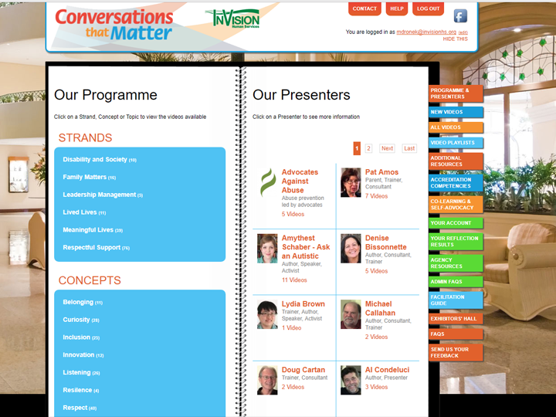

LOGGING ON TO CONVERSATIONS THAT MATTER
FOR THE FIRST TIME

PLEASE NOTE:  In order to log into Conversations that Matter,  you will need 2 things:  1. an email address  2. a password | 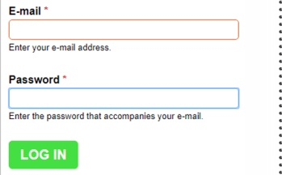

GETTING YOUR INITIAL USERNAME AND PASSWORD
In ##May 2016, each staff member received an email from “Conversations that Matter Support” that included your own individual username (usually your email address) and a temporary password.  If you are unsure of what email address this would have been sent to, please contact ##your coordinator at someone@email.org. | 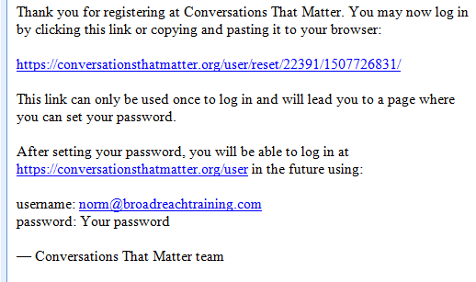

WHAT IF I CAN'T FIND THE EMAIL WITH MY TEMPORARY PASSWORD?
If you have not received your email with your password…  - Check your junk mail or Spam folder. Online mail servers like Hotmail often direct Conversations that Matter emails to the junk mail folder.  - If you did not find it in your junk mail,  it easy to receive another email with a new temporary password. Go to the next page for instructions on how to do this. | 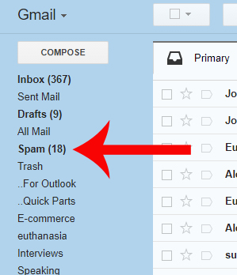

HOW DO I GET A NEW PASSWORD?
What if the email with my password not in my spam folder?
No Problem!!
It's really easy to receive another email with a new temporary password.
Just do this:
- Go to www.conversationsthatmatter.org
- Click on LOG IN NOW link
on the top right side corner of your screen
- Click on the Forget your password? link.

On the next page:
- Enter your email address
RESET YOUR PASSWORD
- Click the
button.
You will immediately receive another email with a link that will take you to a page where you can reset your password.  REMEMBER! If the email doesn't show up in your Inbox, Check Your Spam Folder!  - Click on the link in the email  to reset your password. | 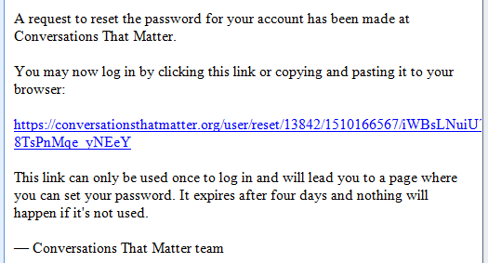
This link will take you to a page in the website where you'll be able to reset your password.
- Enter your email address.
- Enter your new password.
- Re-enter your new password.
SAVE
- Click the button.

This link in this email expires after 4 days, so reset your password as soon as you get the email.

HOW DO I CHANGE MY EMAIL ADDRESS?
YOUR ACCOUNT  Click on the tab  on the right side of the booklet. | 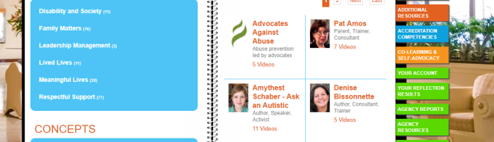
On the next page:  - Click the  EDIT YOUR ACCOUNT  button. |  |  | 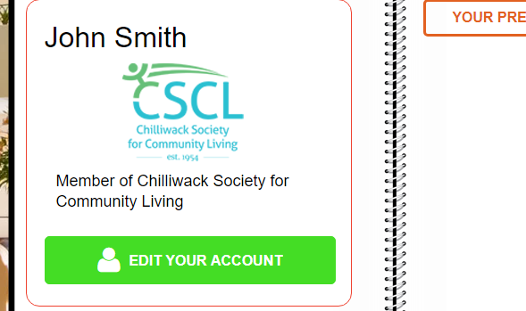
On the next page:  - Type in your password.  - Type in your new email address.  SAVE  - Click the button |  | 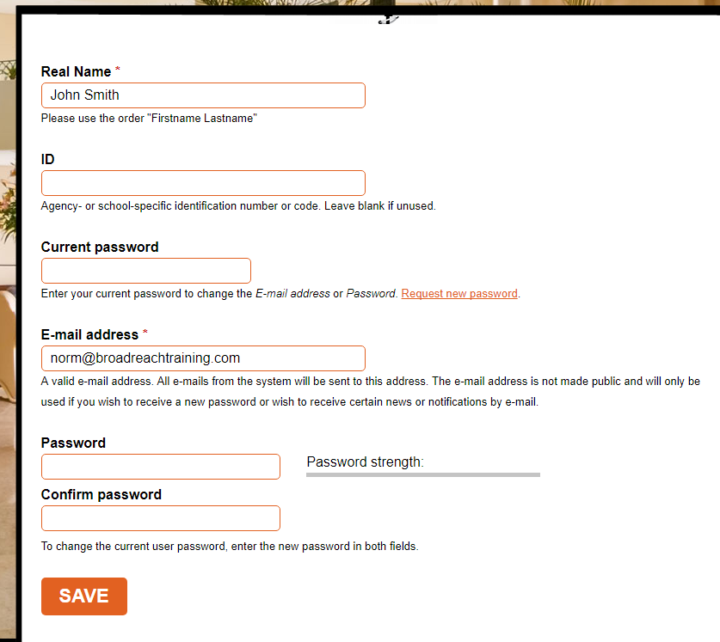  jsmith@someagency.org

WHAT DO I DO WHEN I GET AN ERROR MESSAGE
WHEN I TRY TO LOGIN?
I tried to login but I got an error message saying my email address or password wasn't recognized.
Usually, agencies sign up staff members using their work email address.  If you got an error message saying that your email or password wasn't recognized, it likely means that you're trying to login with an email address that is different from the email address that was used to subscribe you to the site.  Try using your work email address or another email address you may have.  If that doesn't work, contact ##your rep at someone@email.org to see what email address was used to register you on the site. | 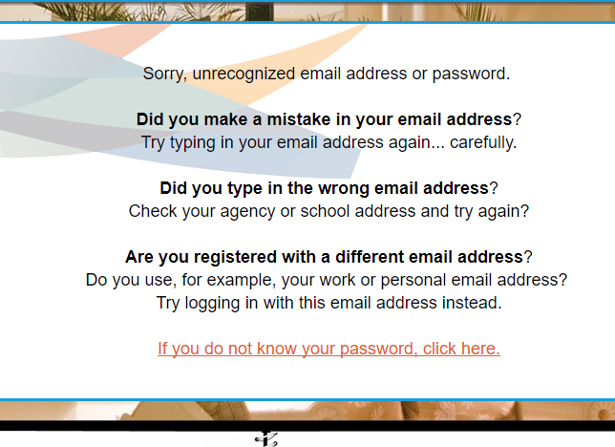

LOGGING IN TO CONVERSATIONS THAT MATTER
Once you have your email address and password:  - Go to the Conversations that Matter  website at www.conversationsthatmatter.org  - Click on LOG IN NOW link  on the top right side corner of your screen. | 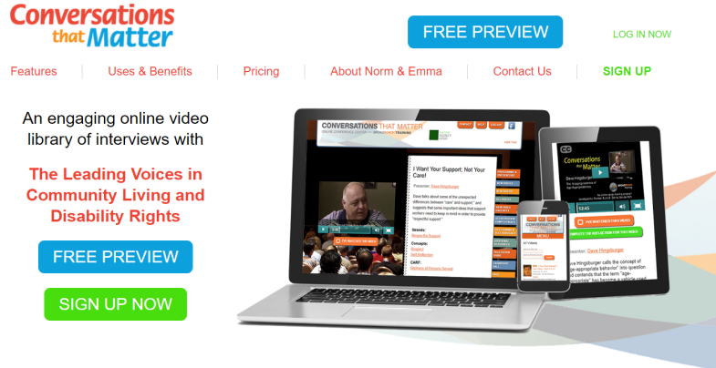
- Enter your email address.

- Enter your password.
LOGIN
- Click the button.

Congratulations!  If you're reading this, it means that you've successfully logged into Conversations that Matter.  Every time you log in, you'll be taken to your opening page where you can:  - Click on the button to change your name (if you got married), change your email address, or change your password.  YOUR PREVIOUSLY WATCHED VIDEOS  EDIT YOUR ACCOUNT  - Click on the  button t o see a list of the videos you've already watched.  PROGRAMME & PRESENTERS  - Click on the tab  to begin watching videos.  You can get back to this page at any time by clicking on the tab  YOUR ACCOUNT  on the right side of the booklet. | 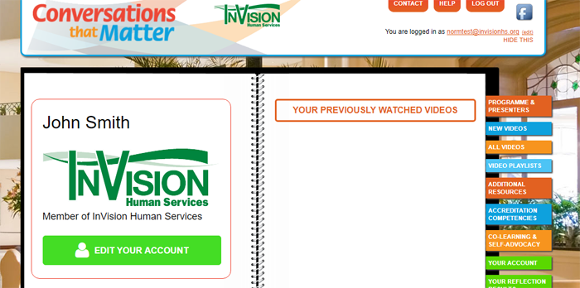

HOW TO SELECT & WATCH A VIDEO
Now it's time to select a video to watch!
There a many ways to select videos to watch:
1. You can click on a Presenter
and choose a video of a conversation with that person
or
2. You can click on any link in the Strands, Concepts, & Topics
sections to watch videos on a
specific topic
or
3. You can select a video from a
tab
VIDEO PLAYLISTS
or
4. You can click on the
tab
ACCREDITATION
COMPETENCIES

to select a video on a specific Accreditation Competency

When you click on a Presenter or a Topic, you'll be taken to list of videos and their descriptions.  Click on the button  WATCH NOW  to begin watching that video. | 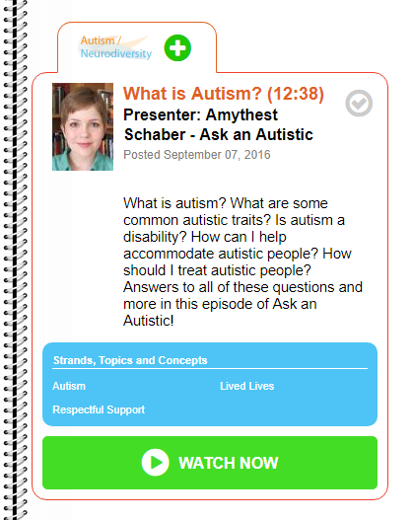

PLAYING A VIDEO
Click on the BLUE PLAY  button to begin watching the video.  When you move your mouse over the video, a control panel will appear  at the bottom of the video.  Click on the BLUE PLAY/PAUSE  button to Pause or Play the video.  You can drag the BLUE SLIDER  back and forth to go to different parts of the video.  You can click on the BLUE ICON  in the bottom right corner of the video to change the video to FULL SCREEN or bact to a SMALLER SCREEN .  Be aware, though, in full screen mode  the video may stall and start repeatedly if you have a weak internet connection. If this happens, go back to the SMALLER SCREEN. | 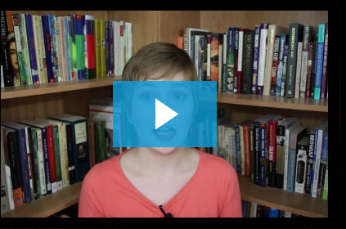  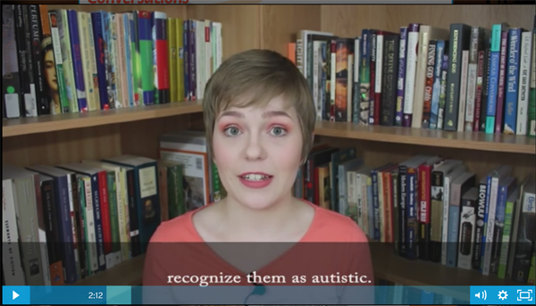

MARKING A VIDEO AS "WATCHED"
Once you've finished watching a video,  you have the option of marking that video as "watched" so you'll always know which videos you've watched.  To show that you've watched this video,  click on the icon.  Once you've clicked the grey icon,  it will turn green  This shows that you've watched this video.  If you click on the tab  YOUR ACCOUNT  and then click on  YOUR PREVIOUSLY WATCHED VIDEOS  button, this video will show up on the list of  videos you have watched.  PLEASE NOTE: In some agencies, supervisors and Human Resource managers can view reports on which staff members have watched which videos.  You have to mark a video as "watched" in order for it to show up on your supervisors' report. | 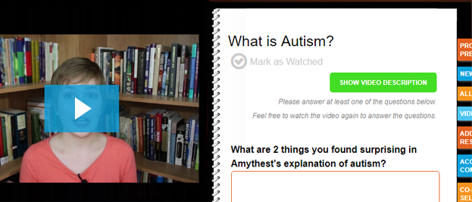  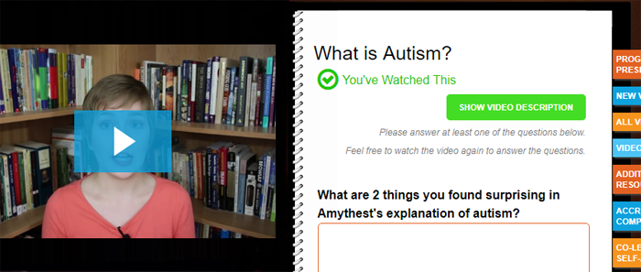  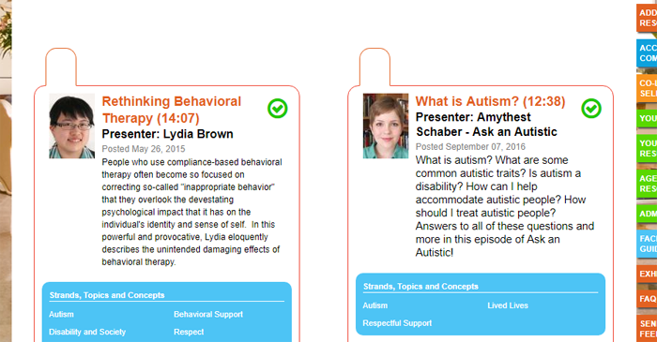  But I did watch that video!

COMPLETING THE REFLECTION QUESTIONS
Once you've finished watching a video, you have the option of answering the reflection questions for that video.  To do this, click on the  \ button.  COMPLETE THE REFLECTION FOR THIS VIDEO  . | 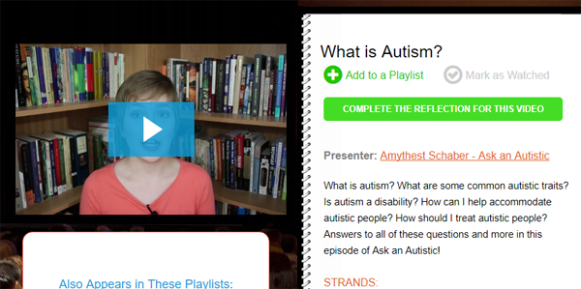
Type your responses into the text boxes.  Click on the box beside to person  or people you want to send your reflections to.  Then click the button.  SEND ANSWERS | 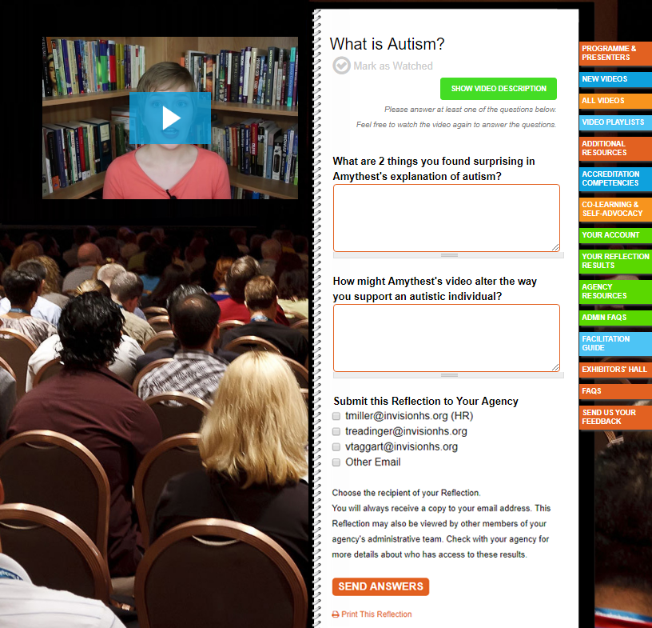

SELECTING VIDEOS FROM A PLAYLIST
As you may already know, a playlist is a series of songs or videos grouped together and arranged in a particular order.  There are a number of playlists on Conversations that Matter that are made up of videos on a specific topics or for specific purposes.  When you first login or when you go to  YOUR ACCOUNT page, you'll see all the playlists that are available to you.  The playlist/s at the top will be your agency's playlist.  The playlists underneath are the playlists that have been set up by Conversations that Matter | 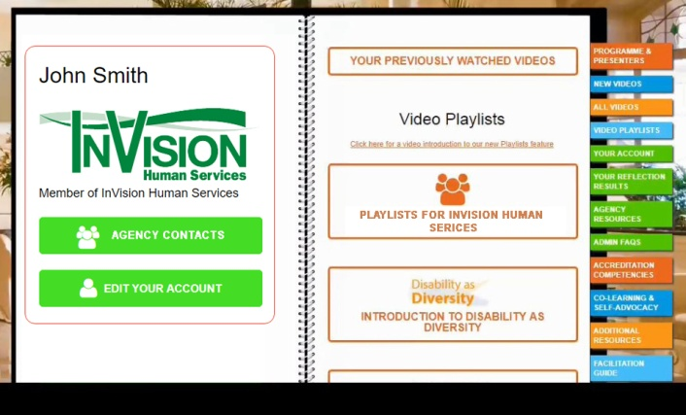
You can also see the list of available playlists by clicking on the tab
VIDEO PLAYLISTS
on the right side of the booklet
.
You will be taken to a page that shows all the playlists that are available to you.  +  Click on the icon  to see the videos in the playlist | 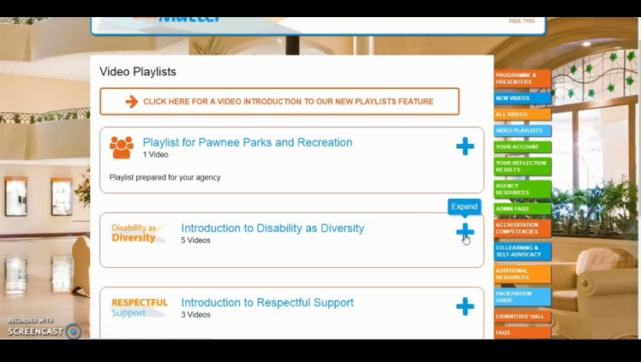
You will see a list of all the videos in the playlist.
+
If you click on the smaller icon

you will see a description of the video  Click on the button  to begin watching that video  WATCH NOW | 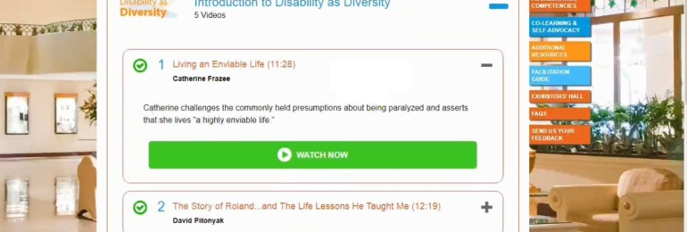

ADDING VIDEOS TO A PLAYLIST
In some cases, an agency may give managers, supervisors, or other people the ability to create a playlist or playlists for their agency.
You may want to create one playlist for orientation and another one for probation that new employees will watch.
If you have been given the ability to
create playlists, you will see a icon
on the top of every video.
Clicking this icon allows you to add that video
to a specific playlist.

When you click the icon, a dialogue box will appear that will allow you to choose which playlist you want to add the video to.
Initially, your agency will only have one playlist. If you would like more playlists for your agency, contact Chris LaVigne, our website administrator, at support@conversationsthatmatter.org

Select the playlist you'd like to add the video to
and click button
ADD TO PLAYLIST

A icon now will always show up on the top of that video indicating that the video belongs to a playlist.
Holding your mouse over the icon will show you what playlist/s that video belongs to.

Like the other playlists, clicking on the icon
will list all the videos in that playlist

REMOVING VIDEOS FROM A PLAYLIST
Hiding the List of Videos  Click on the icon  to hide the list of videos.  Removing Videos from a Playlist  Click on the icon  to remove that video from the playlist. | 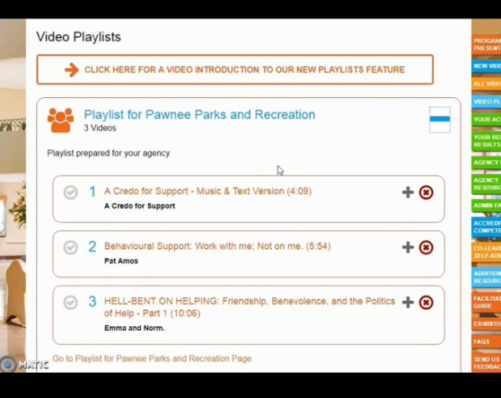

VIEWING AGENCY REPORTS
If your agency has given managers or supervisors administrative privileges, they will
AGENCY REPORTS
have an tab
on the right side of the booklet.

By clicking on this tab, managers or supervisors will be able to view reports on which staff members have watched which videos.  If you click on the button,  VIEW | 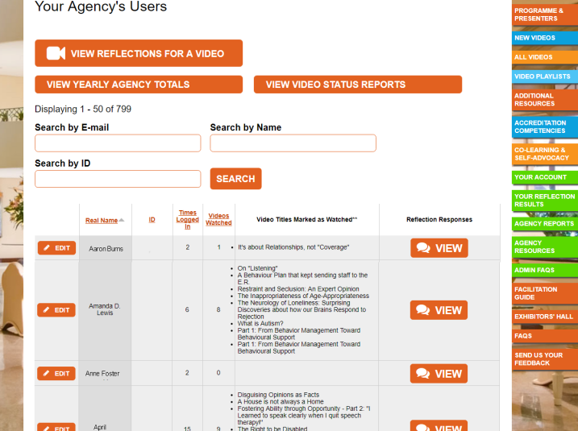
you will be able to view various staff member's responses to the reflection questions. | 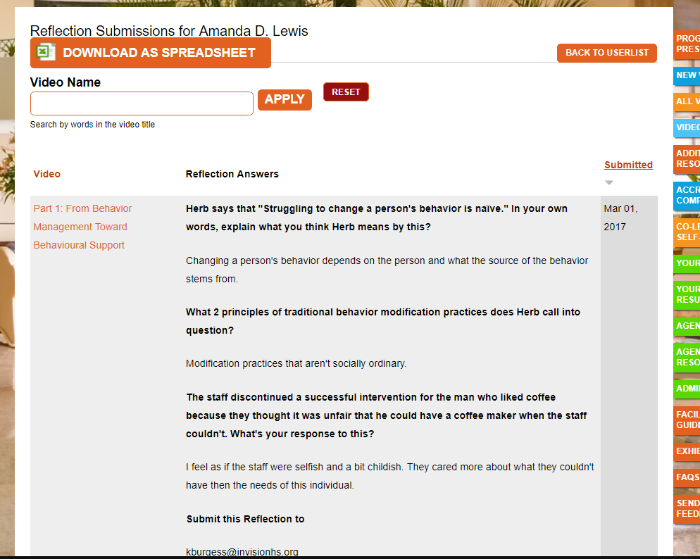

YOUR AGENCY CONTACTS
If you still need help logging into or using Conversations That Matter, contact your local rep

Your Core Group Members
 | Nicole Hayward  Crystal Joseph  Sheeja Forget  Marianne Horton  Greg Meadows  Riad Wright | Donnie Francis  Franklin Bowen  Suzanne Young  Sherry-Lynn Bartlett  Nicole Carriere  Jennifer Fraser

Your Team A, B, & C Location Reps
Team A |  | Team B |  |  | Team C
Location | Contact | Location |  | Contact | Location |  | Contact
Southdale  Dundas  Bluebell  Eula  Stratford  Greenfield  Kains  Wickerson  Becky  Melinda  Riverside  Waterwheel  Driver | Nicki Pinkerton  Robert Buzzell  Matt Benoit  Dawn Khan  Emily Slaats  Betty Xavier  Maria Wallis  Kathy Roberts  Ashley Lazic  Sacha McCan  Chris Francis  David Hall  Gregg Baker | Hunterwoods  Victoria  Elizabeth  Glenview  Westlake  Timber  Fanshawe  Deveron  Cranbrook  Kimberley |  | Allan Jose  Barb Carrie  Danielle Smit  Kristen Davis  Caitlin Isbister  Shelby Price  Brian Clarke  Kendra Firby  Dianne Brown  Sam Pinnell | Southdale E  Southdale W  Wistow  Plane Tree  Belgrave  Vancouver  Creston  CCM  Eden  Riverside  Poplar  Louise  Hartson |  | Margaret Weber  Stephanie Blais  Angela MacNeil  John Knowles  Katelyn Taylor  Danielle James  Heather Okoko  Natalia Godding  Rose Grech  Andrea Quijalvo  Maria Wessel  Billie Davidson  Kari MacQueen

RESPONSIBILTIES OF REPS AND COORDINATORS
Location Rep
- One year commitment
- Location cheerleader/communicator/liaison
- Support coordinator
- Assist with logging on staff members
- Assist with training CTM to new staff
- Ensure video is picked for each staff meeting (either by themselves, or
others)
- Ensure conversation at staff meeting is facilitated
- Inform coordinator if leaving location or if term is up
Location Coordinator
- Support location rep
- Ensure all staff are registered and are able to log on
- Ensure first item on staff meeting agendas
- Send new staff email to Leslie at the office
- Ensure new staff are registered to CTM, have an understanding of the
importance of the tool, and, within their first 6 weeks, watch a minimum of 5 videos that the location staff feel are valuable and relevant
- Create open atmosphere
- In the event that location rep leaves, find new rep and advise core group member
  - Set up time for training of new rep by a core group member
Senior Coordinators
- Ensure coordinators have their team logged on
- Engage, watch videos, communicate value
- Ensure on staff meeting agendas
- Watch videos during coordinator meetings
- Watch videos during senior coordinator meetings
- Utilize videos when leading other groups (PAR groups, etc)
- Create an open atmosphere.
- Engage in and support conversations

Conversations
that | Matter

FACILITATING DISCUSSIONS

Facilitating
Discussions
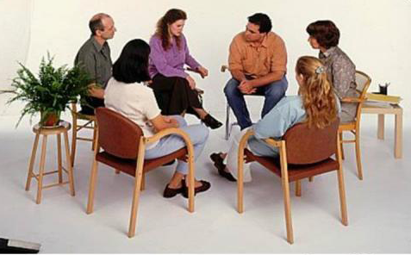

IDEAS FOR FACILITATING ENGAGING AND FUN DISCUSSIONS
Here’s some ideas that we've learned about
how to promote a fun and engaging discussion
around the CTM videos at your location!
Have it as item #1 on staff meeting agendas
- What a better way to start off your staff meeting with some tantalizing conversations!
Create a fun atmosphere
- Popcorn and pop anyone?
Ask questions
- Don’t be afraid to utilize the reflection questions at the end of the video
Be brave!
- Share your own thoughts and ideas
Know your audience
- What videos would your fellow staff members find
interesting?
- Feel the energy in the room
  - Is it time to stay silent?
  - Did it just get awkward and now it’s time to talk?
Ask for help
- We’re here for ya! Contact someone@email.com

CONVERSATIONS THAT MATTER FACILITATED DISCUSSION FORM
Conversations
that | Matter
FOR THIS MONTH’S STAFF MEETING:
DATE: _____________________
STAFF LEADING DISCUSSION:
________________________________________________________________
VIDEOS TO VIEW FOR DISCUSSION:
________________________________________________________________________________________________________________________________________________________________________________________________________________________________________________________________________________________________
FOR NEXT MONTH’S STAFF MEETING:
DATE: _____________________
STAFF LEADING DISCUSSION:
________________________________________________________________
VIDEOS TO VIEW FOR DISCUSSION:
________________________________________________________________________________________________________________________________________________________________________________________________________________________

SUGGESTIONS FOR FACILITATING CONVERSATIONS
What question do I ask?  When people begin learning facilitation skills, they often feel a pressure to “come up with next question.” This is normal. |  | With practice, you’ll find this becomes easier  You’ll find that if you just listen closely and remain curious, subsequent questions will spring to your mind.
Resist the habit of  “chatting.”  Facilitating a conversation has an specific goal, it’s very different than just chatting. |  | Your task is to ask questions that foster Self-Reflection, Insight, & Learning
Resist the “Temptation to Teach”  When we hear problematic attitudes, the temptation is to “correct & teach.” | 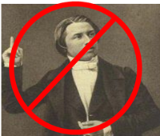 | Probe assumptions with questions instead.
Don't simply ask a series of questions.  We often jump from question to question rather than exploring the response. |  | Go "Deep" rather than "Wide."  Explore the underlying meaning of what is said. | 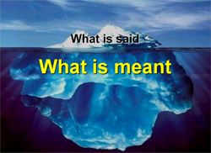
“Hover” on an answer  You can often ask several questions about a single answer. |  | Michael White, a renown psychotherapist, would often ask the same question several times. His clients never got | Michael White
 |  | annoyed. It always brought about more information. He called this “hovering”
Ask a question.  Then Shut-up!  Many of us become anxious when there are periods of prolonged silence. |  | Let the question “hang in the air."We need to practice feeling calm during periods of silence and allow that silence to prompt responses.

FACILITATION QUESTIONS

Facilitating a conversation is like opening a Russian doll.
Each question will reveal something deeper and new.
Here are 6 "types of questions" that can help you
deepen the conversation.
CURIOSITY  What did viewers notice?  “What ‘struck’ you about the video?”  “What stood out for you”?  “When you think about the video, what phrase or idea first comes to mind?”  “Was there anything else?”  “Can you say more about that?”  When _____ said, “________,” what came to mind for you?” |  | SPECIFICITY  Clarify generalizations, opinions, and clichés.  “What was it that you liked about it?”  “Can you elaborate on what you mean by ‘inspiring’?”  “Can you give me an example of what you mean by ‘respectful support?
INSIGHT  What insights were gained.  “What new insights, if any, did you gain from this video?” “  “Can you say more about why that part was important to you?”  “What personal values or beliefs were reinforced by the video?”  “Why did that resonate for you?” |  | EXPERIENCE  Related to personal experiences  or memories.  “Did that part of the video remind you of a personal experience?”  “Can you think of a time in your life when you dealt with a similar issue?”  “Have you seen similar things occur with the people you support?”
ACTION  What action will you take?  “How might this change the way you support someone?  “What is one thing you will do differently because of this video?”  “When would you put this idea into action?” |  | ALTERNATIVES  What new alternatives are possible?  “What new alternatives of supporting individuals were revealed by this video?”  “What kept us from seeing these alternatives before?”  “What other alternatives might be possible?”

PROCESSING MODALITIES

Different Processing Modalities  There are basically 5 different ways that we can receive, understand, and express information and ideas:  - Visual  - Auditory  - Emotionally  - Cognitively  - Kinesthetically |  | 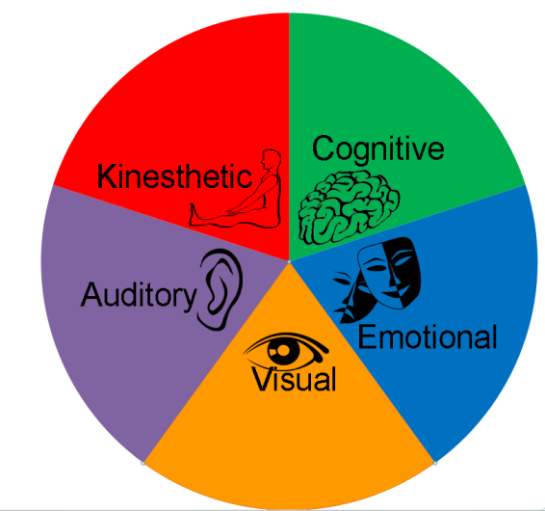
Preferred Processing Modalities  Each of us have preferred ways of receiving, understanding, and expressing information and ideas.  Our preferences are often revealed through the language that we use. So, if a person says," I see what you mean," that usually means that this person's preferred modality is visual. |  | 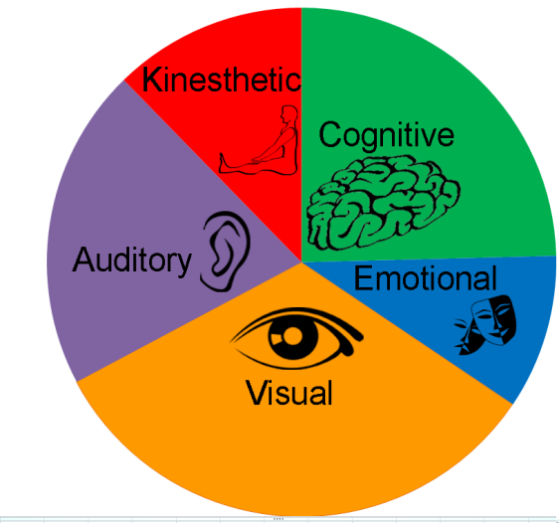
Connecting with a Person through using the Language of the Person's Preferred Modality

If we suspect a person's preferred modality by the language that they use, then our questions may have more relevance for that person if we use the language they prefer.
Visual:  Auditory:  Cognitive:  Emotional:  Kinesthetic: | "What did you see…" " What did that video reveal about…"  "What resonated for you?"  " Were there any parts that spoke to you"  "What do you think were the most important ideas…"  "What comes to mind…"  "What feelings rose up for you when…"  "What emotions were you aware of…  "What struck you about" "What grabbed you" "What stood out"

Conversations
that | Matter

VIDEOS, TOPICS, & SUGGESTIONS

Videos, Topics,
& Suggestions
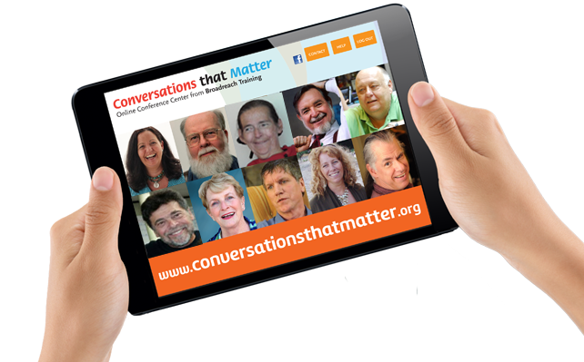

INTRODUCTORY VIDEOS
INTRODUCTION TO "DISABILITY AS DIVERSITY"
- Norman Kunc - The Right to be Disabled (11:27)
- Catherine Frazee - Living an Enviable Life (11:28)
- A Credo for Support (4:30)
- Catherine Frazee - The Illusion of Normalcy (10:51)
- Judith Snow - Disability: An Unusual Gift (12:08)
INTRODUCTION TO RESPECTFUL SUPPORT
- Dave Hingsburger The Politics of Support - Part 1: "This isn't about You" (6:02)
- Dave Hingsburger – “I Want Your Support; Not Your Care! (3:07)
- Catherine Frazee - Providing Personal Care: What Really Matters (7:33)
- David Pitonyak - The Story Of Roland & The Life Lessons He Taught Me (12:19)
INTRODUCTION TO AUTISM / NEURODIVERSITY
- Emily Titon - Autism as Neurodiversity (14:18)
- Amythest Schaber - What is Autism? (12:38)
- Anne Donnellan - Autism as a Movement Difference (13:58)
- Nick Walker - Don't Panic; Trust the Weirdness: Advice for Supporting Autistic Individuals (18:22)
INTRODUCTION TO BEHAVIORAL SUPPORT:
- Herb Lovett - From Behavior Management Toward Behavioural Support (8:46)
- Peter Leidy - A Behaviour Plan that kept sending staff to the E.R. (16:01)
- Sheldon Schwitek - Cross-pollination - What's beekeeping got to do with support? (9:52)
INTRODUCTION TO PERSON-CENTERED PLANNING
- Jack Pearpoint & Lynda Kahn - Person-Centred Planning - : "What it is...
What it's NOT!" (9:45)
- Jack Pearpoint & Lynda Kahn - Person Centered Planning: Part 3 - Listening, Learning & Taking Action (26:40)
- Jack Pearpoint & Lynda Kahn - It Started with Spaghetti (6:24)
- Michael Kendrick - Domains of Needs: A framework for Person Centred Planning (10:15)
INTRODUCTION TO INCLUSION
- Norman Kunc - Fostering Ability Through Opportunity: There Is More To Life Than Life-Skills (14:52)
INTRODUCTION TO JOB DEVELOPMENT
- Denise Bissonnette - The Art of Job Development - Part 1: Becoming Passionate about Possibility (12:35)
- Michael Callahan - Customized Employment: A New Way of Thinking about Paid Work (17:16)
- Pat Amos - Part 2: Following the Golden Thread (11:33)

INTRODUCTION TO SEXUALITY AND RELATIONSHIPS
- Dave Hingsurger - Before we talk about sex… (06:39)
- Dave Hingsburger - Respecting Personal Boundaries (8:54)
- Dave Hingsburger - What's Even More Important than Sex? (9:06)
INTRODUCTION TO INSTUTIONALIZATION
- Fred Ford - The Legacy Of Institutions: What Were They Like? Will They Return? (12:17)
- Fred Ford - Can A Group Home Be An Institution? (9:19)
- Peter Park - Coming Home: A Story Of Institutionalization, Resistance And Resilience (20:40)
INTRODUCTION TO ADVOCACY
- Lynne Seagle - Doing The Wrong Thing Kindly Doesn't Make It Right! (15:27)
- Dave Hingsburger - The Politics of Support -: Providing Real Support for Real Choices (9:11)
- Dave Hingsburger - The Politics Of Support - Part 3: The Dangerous Habits Of Power (6:26)
INTRODUCTION TO MAKING COMMUNITY CONNECTIONS
- Al Condeluci - The Power of Social Capital: 4 Steps to Building Bridges into the Community (12:22)
- John McKnight - Helping People with Disabilities become Connected to Communities (10:45)
- Erin Sheldon - Fostering Friendships and Natural Supports (14:06)

CONTINUED LEARNING VIDEOS
CONTINUED LEARNING ABOUT RESPECTFUL SUPPORT
- Dave Hingsburger - The Politics of Support - Part 2: Providing Real Support for Real Choices (9:11)
- Dave Hingsburger - The Politics Of Support - Part 3: The Dangerous Habits Of Power (6:26)
- Dave Hingsburger - On Listening (02:22)
- Dave Hingsburger - Making a Commitment to Communication: Supporting People who don't Speak (16:18)
- Catherine Frazee - When is a Wheelchair not just a Wheelchair (4:34)
- David Pitonyak - The Neurology of Loneliness: Surprising Discoveries about how our Brains Respond to Rejection (8:40)
- Norman Kunc & Emma Van der Klift - Hell-Bent On Helping: The Politics Of Help (1:16:36)
- David Pitonyak - It's about Relationships, not "Coverage" (4:46)
- Kim Lyster - Language, Labels, and Lies (10:58)
- Emma Van der Klift - Why Socrates would have been a great support worker (2:51)
- Emma Van der Klift - Staying Curious: Part 1 - Asking Powerful Questions (7:14)
- Emma Van der Klift - Staying Curious: Part 2 - Three Dangerous Words (7:14)
- Emma Van der Klift - How Language "Implants" Identity (8:50)
- Thomas Neuville - When Good People Cause Harm: In the Name of Help (15:14)
- Thomas Neuville - When Good People Cause Harm: The Problem of Power (8:28)
- Norman Kunc - Fostering Ability through Opportunity - Part 2: "I Learned to speak clearly when I quit speech therapy!" (7:37)
- Lorna Williams - An Aboriginal Perspective on Diversity, Disability and Invisibility (12:15)
CONTINUED LEARNING ABOUT AUTISM / NEURODIVERSITY
- David Pitonyak - I Can't Get Started; I Can't Stop - Part 1 (14:09)
- David Pitonyak - I Can't Get Started; I Can't Stop - Part 2 (9:09)
- Pat Amos - Dancing on the Autism Spectrum (16:44)
- Pat Amos - Following the Golden Thread (11:33)
- Pat Amos - Autism: Listening to the REAL Experts (07:25)
- Amythest Schaber - Autism and Executive Functioning (10:58)
- Amythest Schaber - What About Eye Contact? (09:40)
- Amythest Schaber - What are Good Therapies (11:14)
- Amythest Schaber - What are Meltdowns? (12:23)
- Amythest Schaber - What is ABA? (09:16)
- Amythest Schaber - What is Autistic Burnout? (09:57)
- Amythest Schaber - What is Central Auditory Processing Disorder? (14:09)
- Amythest Schaber - What is Echolalia? (12:16)
- Amythest Schaber - What is Stimming? (10:34)

CONTINUED LEARNING ABOUT BEHAVIORAL SUPPORT
- Herb Lovett - Pt 2: Supporting Individuals with Serious or Dangerous Behaviour (12:49)
- Herb Lovett - Pt 3: Advice on Advocating for Respectful Support (07:39)
- Herb Lovett - Pt 4 Supporting Individuals with Self-Injurious Behaviour (08:02)
- Lydia Brown - Rethinking Behavioral Therapy (14:07)
- Pat Amos - The Thing We Call "Behaviour" (06:17)
- Lynne Seagle - A House is not always a Home (8:50)
- Pat Amos Part 1 - Dancing on the Autism Spectrum (16:44)
- Dave Hingsburger - The Inappropriateness of Age Appropriateness (12:45)
- David Pitonyak - An unexpected Perspective on Behavioral Support (13:35)
- Ruth Siegfreid / Kim Love - Personalized Behavioral Support without Restraint (12:21)
- Ron Garrison - Restraint and Seclusion: An Expert Opinion (11:52)
CONTINUED LEARNING ABOUT PERSON-CENTERED PLANNING
- Jack Pearpoint & Lynda Kahn - Person Centered Planning: Part 2 - Preparing for The Meeting (9:43)
- Jack Pearpoint & Lynda Kahn - Person-Centered Planning: Part 4 - Checking in (7:45)
- Jack Pearpoint & Lynda Kahn - Person-Centered Planning: Part 5 - Common Concerns about PCP (9:24)
- Jack Pearpoint & Lynda Kahn - Five Valued Experiences
- Michael Kendrick - Developing Reasonable Safeguards for Reasonable Risk (10:17)
CONTINUED LEARNING ABOUT ADVOCACY
- Peter Leidy - Asking The Questions No One Wants To Ask (10:39)
- Thomas Neuville - The Art Of Subversive Support (15:00)
- John O'Brien - Deciding To Make A Difference (21:13)
CONTINUED LEARNING ABOUT JOB DEVELOPMENT
- Michael Callahan - Discovery: The Engine Behind Customized Employment (18:16)
- Denise Bissonnette - The Art of Job Development : Working with Employers (7:06)
- Denise Bissonnette - The Art of Job Development: Working with Job Seekers & Advice for Families (15:40)
- Denise Bissonnette - The Art of Job Development - Part 4: On Becoming a Resilient Job Developer (11:31)
- Denise Bissonnette - A Poem: Blue Skies (5:40)
- Pat Amos - How Dan Became a Scientist (8:41)
CONTINUED LEARNING ABOUT MAKING COMMUNITY CONNECTIONS
- Al Condeluci - With The Best of Intentions (9:17)
- Al Condeluci - Relevance & Regularity: (7:26)

OTHER TOPICS
LEADERSHIP
- Doug Cartan - Accountability Based Management - Part 1: From Responsibility to Accountability (14:47)
- Doug Cartan - Accountability Based Management - Part 2: Four Essential Elements of Trust-Enhancing Workplaces (19:52)
- Sheldon Schwitek - Mentoring Support Workers: The Missing Piece of Training (5:23)
- Kim Lyster - The Question of "Customer Service" (4:33)
- Dave Hingsburger - Deliberate Indifference (8:27)
ETHICAL ISSUES
- Fred Ford - Reporting Neglect And Abuse: Having The Courage To Do The Right Thing (8:20)
- Peter Leidy - Asking The Questions No One Wants To Ask (10:39
- Advocates Against Abuse - Advocates Against Abuse (full length video) (36:13)
- Dave Hingsburger - Disguising Opinions as Facts (02:24)
MANAGING CONFLICT
- Janice Fialka - Fostering Collaborative Parent-Professional Partnerships (17:50)
- Erin Sheldon - Asking New Questions; Finding New Answers (14:48)
- Emma Van der Klift - Managing Conflict Ethically (Upcoming)
DISABILITY AND AGING
- Kim Lyster - Aging & Disability: Ensuring "A Good Life" in the Later Years (17:02)
FOR PARENTS (AND AGENCY STAFF)
- Erin Sheldon - Fostering Friendships and Natural Supports (14:06)
- Erin Sheldon - Asking New Questions; Finding New Answers (14:48)
- Erin Sheldon - Listening Differently: Technology for Communication (12:59)
- Janice Fialka - Fostering Collaborative Parent-Professional Partnerships (17:50)
- Pat Amos - Resisting Stories of Sadness: An alternative Perspective on Raising Autistic children (6:27)
COMMUNITY CONNECTIONS AND MICROBOARDS
- Maria Glaze Microboards - Part 1: Benefits, Challenges, and Lessons (18:04)
- Maria Glaze Microboards - Part 2: Building a Successful Team (18:34)
- Linda Perry Microboards - Part 1: A Flexible Alternative to Traditional Services (14:07)
- Linda Perry Microboards - Part 2: Stories and Lessons Learned (15:49)
- John McKnight - Community, Systems, Service, and Care. (15:31)
- John Lord - Part 1: Working Towards a "New Story" of Support (17:16)
- John Lord - Part 2: Creating a "3rd Alternative" (13:44)

VIDEOS SUGGESTIONS, AS RECOMMENDED BY THE ##PHSS CORE GROUP

Video | Presenter(s)
Providing Personal Care: What Really Matters | Catherine Frazee
It Started With Spaghetti | Jack Pearpoint  and Lynda Kahn
The Politics Of Support, Part 1 This Isn’t About You | Dave Hingsburger
Doing The Wrong Thing Kindly, Doesn’t Make It Right | Lynn Seagle
The Questions No One Wants To Ask | Peter Leidy
Asking New Questions: Finding New Answers | Erin Sheldon
Rethinking Behavioral Therapy | Lydia Brown
Autism – Listening To The Real Experts | Pat Amos
A Behavior Plan That Kept Sending Staff To The ER | Peter Leidy
Staying Curious Part 2 – Three Dangerous Words | Emma Van Der Klift
Disguising Opinion As Fact | David Hingsburger
Making A Commitment To Communication: Supporting People Who Don’t Speak | David Hingsburger
Respectful Support: What Really Matters | Catherine Frazee
Credo Of Support | A Video by Norman Kunc  and Emma Van Der Klift
Accountability Based Management Part 1:  From Responsibility To Accountability | Doug Cartan

TROUBLESHOOTING & STAFF CHANGES FORM | Conversations
 | that | Matter
Coordinators/Location Rep
If required, please complete and send to Leslie (either via fax 519-660-1654 or email leslieg@participationhouse.com)

Location _______________________________________ Coordinator/Location Rep__________________________________
For those who still require assistance with password or logging on
Name | Log-in Email |  | Did you attempt to re-set your password? | Result (error message?) |  | Other issues identified
 |  |  | Y / N
 |  |  | Y / N
 |  |  | Y / N
 |  |  | Y / N
 |  |  | Y / N
 |  |  | Y / N
New/Resigned staff
Name |  | Email address |  |  | New (N) Remove (R) |  | Questions/Comments (if any)
 |  |  |  |  | N / R
 |  |  |  |  | N / R
 |  |  |  |  | N / R
 |  |  |  |  | N / R
 |  |  |  |  | N / R
 |  |  |  |  | N / R

